6.80: The students do positive work, and the force that they exert makes an angle of 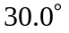 with the direction of motion. Gravity does negative work, and is at an angle of 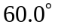 with the chair’s motion, so the total work done is , and so the speed at the top of the ramp is
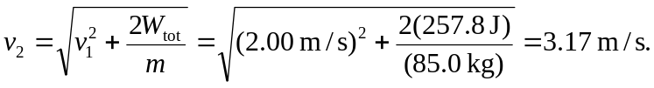
Note that extra figures were kept in the intermediate calculation to avoid roundoff error.

